PHYSICS 2, CHAPTER 4
ADDITIONAL PROBLEMS

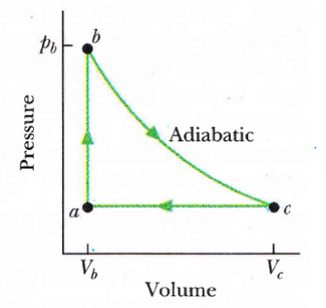
1. Figure 1 shows a reversible cycle through which 1.00 mol of a monatomic ideal gas is taken. Volume V_{c} = 8.00V_{b}. Process bc is an adiabatic expansion, with p_{b} = 10.0 atm and V_{b} = 1.00 × 10⁻³ m³.
Fig. 1
For the cycle, find
(a) the energy added to the gas as heat,
(b) the energy leaving the gas as heat,
(c) the net work done by the gas, and
(d) the efficiency of the cycle.
ANSWER: (a) 1.47 kJ; (b) 554 J; (c) 918 J; (d) 62.4%
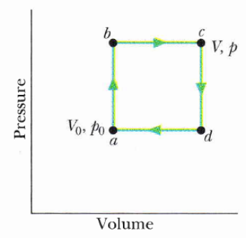
2. Figure 2 shows a reversible cycle through which 1.00 mol of a monatomic ideal gas is taken. Assume that p = 2p_{o} , V = 2V_{o},
Fig. 2
p_{o} = 1.01 × 10⁵ Pa, and V_{o} = 0.0225 m³.
Calculate
(a) the work done during the cycle,
(b) the energy added as heat during stroke abc, and
(c) the efficiency of the cycle.
(d) What is the efficiency of a Carnot engine
operating between the highest and lowest temperatures that occur in the cycle?
(e) Is this greater than or less than the efficiency calculated in (c)?
ANSWER: (a) 2.21 kJ; (b) 14.8 kJ; (c) 1,5.4%; (d) 7 5.0%;(e) greater

3. A 2.50 mol sample of an ideal gas expands reversibly and isothermally at 360 K until its volume is doubled. What is the increase in entropy of the gas?
ANSWER: 74.4 J/K
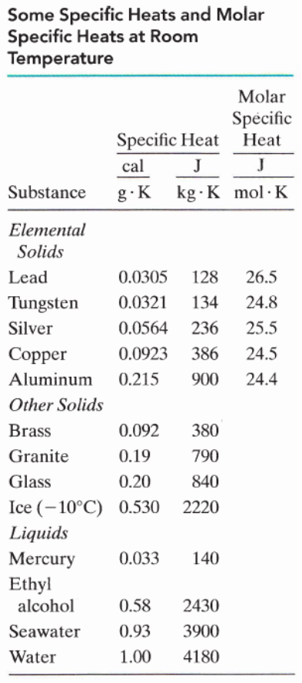
4. Suppose 4.00 mol of an ideal gas undergoes a reversible isothermal expansion from volume V₁ to volume V₂ = 2.00V₁ at temperature T = 400 K. Find
(a) the work done by the gas and
(b) the entropy change of the gas.
(c) If the expansion is reversible and adiabatic instead of isothermal, what is the entropy change of the gas?
ANSWER: (a) 9.22 kJ; (b) 23.1 J/K; (c) 0
5. A 10 g ice cube at -10ºC is placed in a lake whose temperature is 15ºC. Calculate the change in entropy of the cube-lake system as the ice cube comes to thermal equilibrium with the lake. The specific heat of ice is 2220 J/kg.K.
ANSWER: + 0.76 J/K
6. A 50.0 g block of copper whose temperature is 400 K is placed in an insulating box with a
100 g block of lead whose temperature is 200 K. See Table.
(a) What is the equilibrium temperature of the two-block system?
(b) What is the change in the internal energy of the system between the initial state and the equilibrium state?
(c) What is the change in the entropy of the system?
ANSWER: (a) 320 K; (b) 0; (c) +1.72 J/K

